| Ousmane Toure & Jianning Chen  EECE2160 | Embedded Design: Enabling Robotics  Prelab Assignment 5 |
| --- | --- |

Lab Assignment 5

Prelab

Ousmane Toure & Jianning Chen

[Toure.o@northeastern.edu](mailto:Toure.o@northeastern.edu)

chen.jiann@northeastern.edu

Submit date: 6/7/2022

Due Date: 6/7/2022

**5.0 Code/Schematics**

**PRELAB CODE:**

#include <iostream>

#include <string>

#include <stdio.h>

#include <stdlib.h>

#include <time.h>

using namespace std;

double *v;

int count;

int size;

void Shrink();

void InsertElement();

void RemoveElement();

void PrintVector();

void Grow();

void Initialize();

void Finalize();

void Shrink() {

}

void InsertElement() {

}

void RemoveElement() {

}

void AddElement() {

}

void PrintVector() {

}

void Grow() {

}

void Initialize() {

size = 2;

v = new double[size];

v[0] = 0;

v[1] = 1;

}

void Finalize() {

delete[] v;

}

int main() {

Initialize();

int condition;

bool plays = true;

while(plays){

cout<<"Select an option: "<<endl;

std::cout << "1. Print the Array" << std::endl;

std::cout << "2. Append element at the end "<< std::endl;

std::cout << "3. Remove last element" << std::endl;

std::cout << "4. Insert one element" << std::endl;

std::cout << "5. Exit" << std::endl;

std::cin >> condition;

switch(condition){

case 1: {

cout<<"You selected \" Print the Array \""<< endl;

break;

}

case 2: {

cout<<"You selected \" Append element at the end \""<< endl;

break;

}

case 3: {

cout<<"You selected \" Remove last element \""<< endl;

break;

}

case 4: {

cout<<"You selected \" Insert one element \""<< endl;

break;

}

case 5: {

cout<<"You selected \" Exit \""<< endl;

plays = false;

break;

}

default:

cout<<"Please select a proper selection"<< endl;

}

}

Finalize();

return 0;

}

**PreLab 5:**

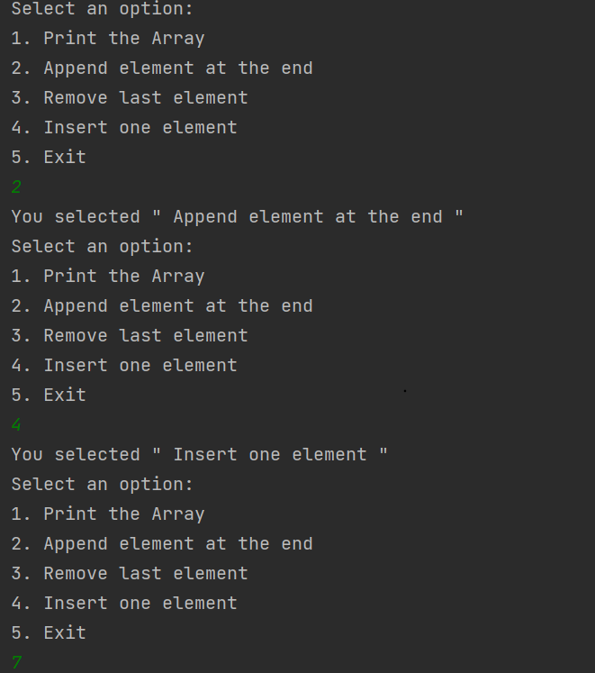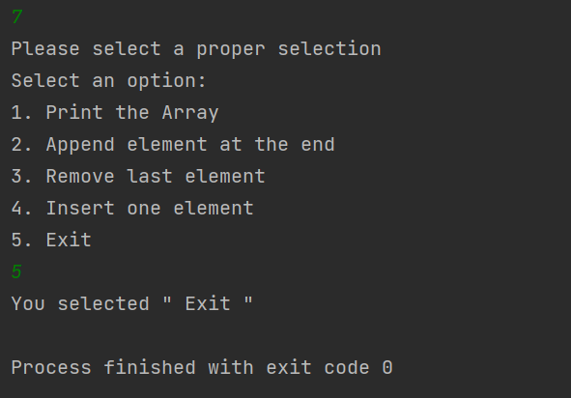

# References

1. Prof. Julius Marpaung, “*Lab Report Guide*”, Northeastern University, January 6 2020.